The proposal states the problem or issue, limits the scope of the project to a  
geographic area and specific purposes. State the intended advanced analysis  
technique from step 5 above. List data, specific sources, and confirmation that  
you have obtained the data. Some of the text in the proposal can be reused in the project’s report. Note that the details of analysis tools can change slightly as you work on the project

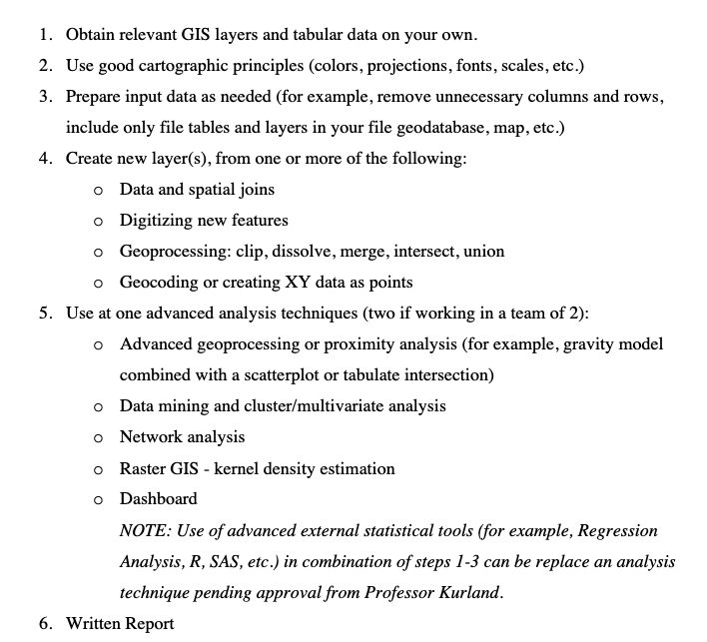

s

